

Assessment Cover Page

Student Full Name | Kevin De Araujo Sanchez
Student Number | 2022271
Module Title | PSI
Assessment Title | CA 2 – Capstone Project
Assessment Due Date | 29/05/2026
Date of Submission | x/05/2026
Declaration
By submitting this assessment, I confirm that I have read the CCT policy on academic misconduct and understand the implications of submitting work that is not my own or does not appropriately reference material taken from a third party or other source.
I declare it to be my own work and that all material from third parties has been appropriately referenced.
I further confirm that this work has not previously been submitted for assessment by myself or someone else in CCT College Dublin or any other higher education institution.

Contents
Abstract 1
Project Objectives 1
CRISP-DM Stage 1 – Bussiness Understanding 1
Business Objective 1
Project Plan – Business Perspective 2
Business Success Criteria 2
Stakeholders 2
Deliverables 3
Inventory of Resources 3
Requirements, Assumptions, and Constraints 3
Risks and Contingencies 3
Terminology 4
Cost and Benefits 4
Data Mining Goals 5
Machine Learning Success Criteria 5
Technical Project Plan 5
Tools and Techniques 5
AWS Deployment Consideration 5
Legal and Ethical Issues 6
CRISP-DM Stage 2 – Data Understanding 7
Data Collection 7
Data Exploration 7
Business Overview 7
Time-Based Analysis 8
Product Performance Analysis 8
Customer Behaviour Analysis 9
Basket Structure Analysis 9
Country Analysis 9
Data Quality 10
Conclusion 10
CRISP-DM – Stage 3 11
CRISP-DM – Stage 4 11
CRISP-DM – Stage 5 11
CRISP-DM – Stage 6 11
References 11

Abstract
This project explores the use of data analytics and machine learning to generate operational insights from transactional data in a hospitality context, using the Online Retail II dataset as a proxy for POS data. Following the CRISP-DM methodology, the project covers data cleaning, exploration, feature engineering, and recommendation analysis to support product performance evaluation, customer behaviour understanding, waste reduction, and upselling strategies. Analytical techniques such as clustering and association rule mining are applied to enhance business insight generation. While the primary goal is to build an analytical solution, the project also examines the feasibility of deploying such a system in a cloud environment using Amazon Web Services. The outcome is a proof-of-concept that demonstrates how transactional data can be leveraged to support data-driven decision-making and improve operational efficiency in hospitality.

Project Objectives
“To develop a cloud-based AI and data analytics layer that transforms POS-style transactional data into operational insights to support customer segmentation, product performance analysis, waste reduction, and upselling recommendations in hospitality businesses.”

CRISP-DM Stage 1 – Bussiness Understanding
The Hospitality Industry is always evolving in ways to serve and to generate income. Several Hospitality businesses are already using POS (Point-Of-Sales) systems as the backbone of their operations (Collard, 2025). Even though large volumes of transactional data are being collected through the POS systems, most owners and managers are still relying on their intuition and experience to make decisions instead of a structured and technical analysis.
This project aims to aid Hospitality leaders, backing up their experience and intuition by transforming POS raw transactional data into actionable insights to support their operational decision-making. The focus is on customer behaviour analysis, product performance evaluation, waste reduction, and upselling opportunities. In addition, the project explores how the solution could be implemented and delivered through a scalable cloud-based architecture, using Amazon Web Services (AWS) as a conceptual deployment environment.
This first stage defines the business objectives, stakeholders, success criteria, and constraints of the project, structured and aligned to the CRISP-DM methodology.

Business Objective
The main goal of the project is to develop a functional data analytics and machine learning solution that enables transactional data to be used in a technical and professional way to support better operational decisions in Hospitality by owners and managers.
The second objective is to demonstrate how such a solution could be deployed in a cloud environment, enabling scalability, accessibility, and integration with different existing business systems.
Summarizing the objectives:
- Segment customers based on purchasing behaviour to support business strategy and targeted decision-making,
- Identify slow-moving products to reduce waste and improve inventory efficiency,
- Analyse product performance to support data-driven menu optimisation,
- Detect relationships between products to support upselling and product recommendation strategies,
- Demonstrate how the solution could be integrated into a scalable AWS cloud environment.
The long-term goal of such system would be integrating a cloud-based solution with an existing POS system, allowing businesses to extract and use their valuable data to their advantage without requiring advanced technological technical skills and a dedicated private server to handle data.

Project Plan – Business Perspective
The project will follow the CRISP-DM methodology, going through:
- Business Understanding
- Data Understanding,
- Data preparation,
- Modelling,
- Evaluation,
- Deployment.
It’s an iterative process, especially between data preparation and modelling, where insights might affect and require adjustments onto earlier stages.

Business Success Criteria
The success of the project, from a business perspective, will be based on the usefulness and applicability of the insights generated. Key criteria include:
- Identification of high-performing and low-performing products,
- Generating actionable insights that support decision-making,
- Being able to highlight opportunities for waste reduction and revenue optimisation,
- Clear and interpretable outputs for non-technical users,
- Being able to deliver insights through a cloud-based solution,
- Ability to identify meaningful customer groups based on purchasing behaviour,
- Ability to generate useful product recommendations through association analysis,
- Outputs that support business interpretation and strategic decision-making.

Stakeholders
The main stakeholders involved in this project are:
- Hospitality Business Owners looking for professional ways to improve their operation,
- Management team responsible for stock planning, menu design, and daily operations,
- Data analysts or technical teams responsible for business strategy,
- Cloud engineers or IT teams responsible for deployment and system integration,
- Customers benefiting from improved product availability and optimised service.

Deliverables
A data analytics and machine learning model able to generate operational insights from transactional data. A structured dataset prepared for analysis and modelling. A set of visualisations highlighting key business insights. A conceptual cloud deployment architecture using AWS services. A detailed project report documenting all decisions and stages of CRISP-DM.

Inventory of Resources
Data: Online_Retail_II dataset.
Tools and Software: Python, Pandas, Numpy, Scikit-Learn, Data Visualisation Libraries.
Cloud Platform: Amazon Web Services (AWS), conceptually including S3 for storage and potential deployment services.
Hardware: Personal Computer.
Personnel: Project author.

Requirements, Assumptions, and Constraints
Requirements: Deliver a functional analytics and machine learning solution. Provide interpretable insights aligned with the project goals. Document all stages following CRISP-DM methodology.
Assumptions: Retail transactional data is similar enough to hospitality POS data. Customer purchasing behaviour and transactional patterns can be meaningfully analysed through historical data. Product purchasing behaviour follows identifiable patterns. Model evaluation metric reflects meaningful business performance. Product correlation within invoices can support recommendation and upselling strategies. Cloud infrastructure can support scalable deployment of such solutions.
Constraints: Time. Dataset is not from a true hospitality business. Data quality issues are present in the raw dataset. No real-time POS integration. Missing Customer ID values may reduce the amount of usable data for customer segmentation. Restricted access to some webservices in the student lab limits the cloud deployment to a proof-of-concept level only.

Risks and Contingencies
Risk | Impact | Mitigation
Poor data quality | Reduced model performance | Data Cleaning
Retail Dataset | Not 100% equal to a Hospitality one | Clearly define scope and limitations
Weak clustering or segmentation quality | Poor business interpretation | Test multiple clustering configurations and evaluate segmentation quality
Time constraints | Incomplete implementation | Prioritise core modelling tasks
Cloud complexity | Delays in deployment | Limit to simplified implementation

Terminology
POS: Point-Of-Sale, system used to perform several actions such as record transactions, take payments, generate reports, etc.
Machine Learning: Subset of AI that enables systems to learn from data, identify patterns and make decisions or predictions without being explicitly programmed.
Customer Segmentation: Process of grouping customers based on a feature.
Association Rules: Technique used to identify products frequently purchased together.
Clustering: Machine Learning technique used to group similar data points.
RFM Analysis: Behavioural analysis based on Recency, Frequency, and Monetary value.
Feature Engineering: Process of creating new variables for modelling.
AWS: Amazon Web Services.
Dataset: Structured collection of related data.

Cost and Benefits
Costs: Development time. Effort. Potential cloud infrastructure costs in real implementation. Integration complexity with existing POS systems.
Benefits: Improved operational efficiency. Reduction of waste and improved sustainability. Increased revenue through better decision-making. Scalable delivery of insights via cloud infrastructure.
There are more benefits than costs if the goal is to increase profit, sustainability, back up better decision-making, and increase competitive advantage.

Data Mining Goals
To support the business objectives, the project will analyse customer purchasing behaviour through customer segmentation techniques such as RFM analysis and clustering. In addition, aggregation and ranking methods will be applied to evaluate product performance, while association rule mining will be used to detect relationships between products and support upselling recommendations. Feature engineering techniques will also be applied to improve analytical performance and business interpretability.

Machine Learning Success Criteria
The success of the machine learning model will be evaluated based on the interpretability and usefulness of the generated customer segments, stability across validation techniques, and the quality of the recommendation outputs. Clustering quality metric such as silhouette score may be used to assess segmentation performance. Association rules will also be evaluated using support, confidence, and lift to ensure meaningful business relevance.

Technical Project Plan
The project will follow an iterative workflow of: Data Understanding > Data Preparation > Modelling > Evaluation. The whole flow will take approximately 5 weeks.
Iteration between Data Preparation and Modelling is expected to consume loads of time. The result of the Evaluation might require revisiting earlier steps.
Dependencies that might influence time and focus: data quality impacting model performance, feature engineering influencing predictive accuracy, and model results influencing evaluation and deployment decisions.

Tools and Techniques
The project will primarily use open-source tools: Python for data processing and modelling. Pandas and NumPy for data manipulation. Scikit-Learn for machine learning models. Machine learning and analytical techniques expected to be used include clustering algorithms such as K-Means, RFM customer analysis, aggregation techniques, and association rule mining methods such as Apriori.
Cloud technologies will be used to conceptually support Data Storage (S3), Model output management, and scalable deployment architecture on AWS.

AWS Deployment Consideration
Even though the focus of the project is data analytics and machine learning, the solution is designed with cloud deployment in mind. The cloud layer will mainly focus on storage of the dataset, processed outputs, and analytical artefacts using Amazon S3, while maintaining local development for analytical processing and modelling.
The objective is not to build a full production system, but to demonstrate the feasibility of deploying such a solution in a scalable cloud environment.

Legal and Ethical Issues
Legal and Ethical Issues are always a concern whenever personal data is involved. When it comes to POS systems the main legal issues involve compliance with the GDPR. Businesses should only collect necessary information and handle them carefully and responsibly. Depending on the POS system, it can store personal information such as names, emails, and even birthdates. The establishment must ensure the collected data is consented and securely processed. Failure to comply with GDPR results in serious legal penalties and reputational damage (BartenderPos, 2025).
POS systems are exposed to security threats such as malware attacks, phishing scams, weak passwords, outdated software and even physical tampering. The most common ways of strengthening the POS system is to keep the software updated, use encryption, enforce strong user access controls, having a secure network, regularly backing up the data and also training the staff handling the devices (McGuire S., 2025).
It’s a shared responsibility between POS system providers and establishments. Both parts have their respective responsibilities in keeping data safe and complying with regulations and data protection standards. Adding an AI layer on top of a POS system implies adding more responsibility regarding the collected, stored and processed data. It adds another layer of accountability and all previous mentioned threats and ways of avoiding them should be even more observed.

CRISP-DM Stage 2 – Data Understanding

Data Collection
The data to be used in this project was obtained from the UCI Machine Learning Repository, a trustworthy academic archive of machine learning datasets. The selected dataset is called Online Retail II and it contains over half a million anonymised transactional records including product identifiers, quantities purchased, timestamps, and unit prices. The dataset contains transactional records from a UK based online retail company between December 2009 and December 2010. The data was imported into Pythin using Pandas library and initially contained 525,461 rows and 8 columns.
Even though the dataset is originally from the retail sector, its transactional structure is very close to a POS system. The transactional nature of the dataset makes it suitable for business analytics, customer behaviour analysis, recommendations systems, and customer segmentation. Since the dataset contains real commercial transactions from an e-commerce environment, it provides meaningful behavioural and purchasing patterns that can support machine learning and business intelligence objectives.
Dataset: https://archive.ics.uci.edu/dataset/502/online+retail+ii
License: https://creativecommons.org/licenses/by/4.0/legalcode
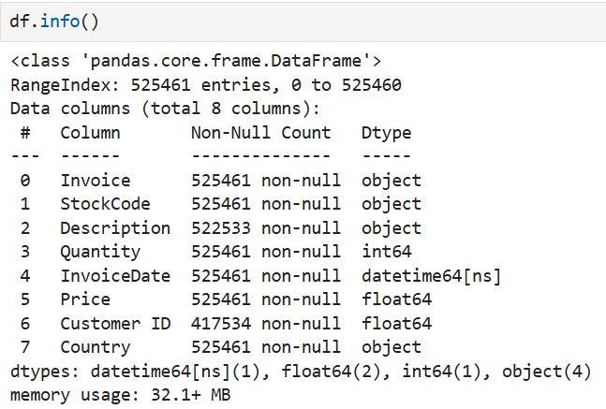
Figure 1: Dataset Information

Data Exploration

Business Overview
After the cleaning process the final transactional dataset contained 504,730 rows and 9 columns. The dataset generated over £10.27 million in revenue across 20,951 invoices and included 4,251 unique products and 4,312 identifiable customers across 40 countries. The results indicate that the dataset contains enough commercial and behavioural data for machine learning and analytical modelling.
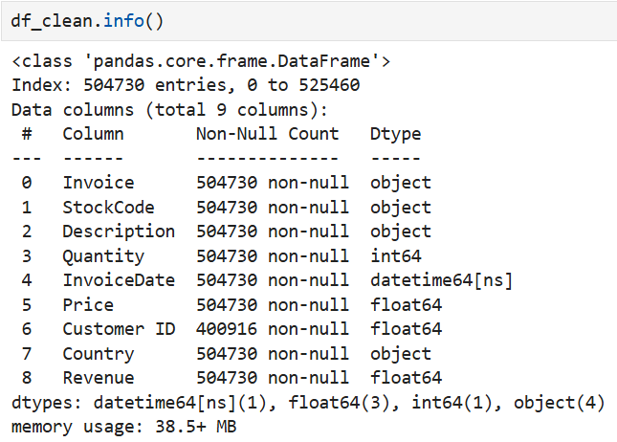
Figure 2: Cleaned Dataset

Time-Based Analysis
Monthly analysis identified strong growth in revenue, quantity sold, and invoice activity between September and November 2010. November represented the highest commercial activity period. December 2010 presented lower values because the dataset only contains records until the 9th of December.
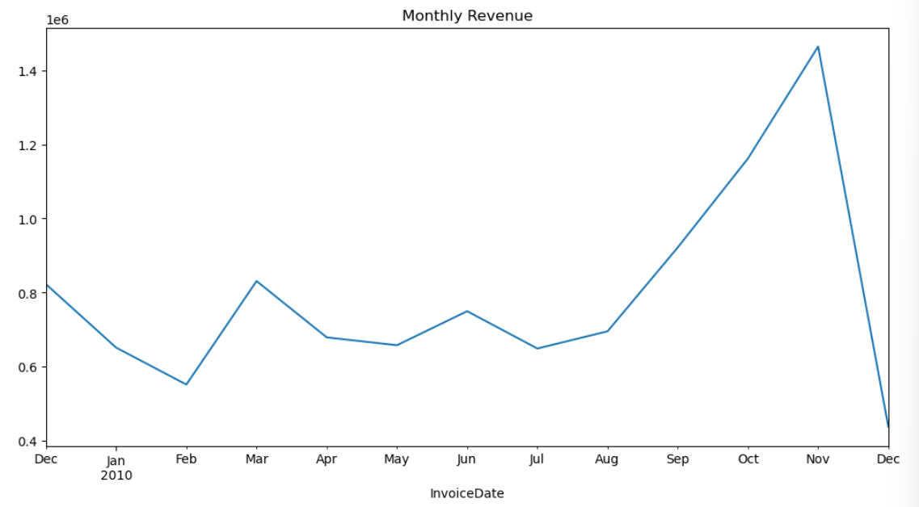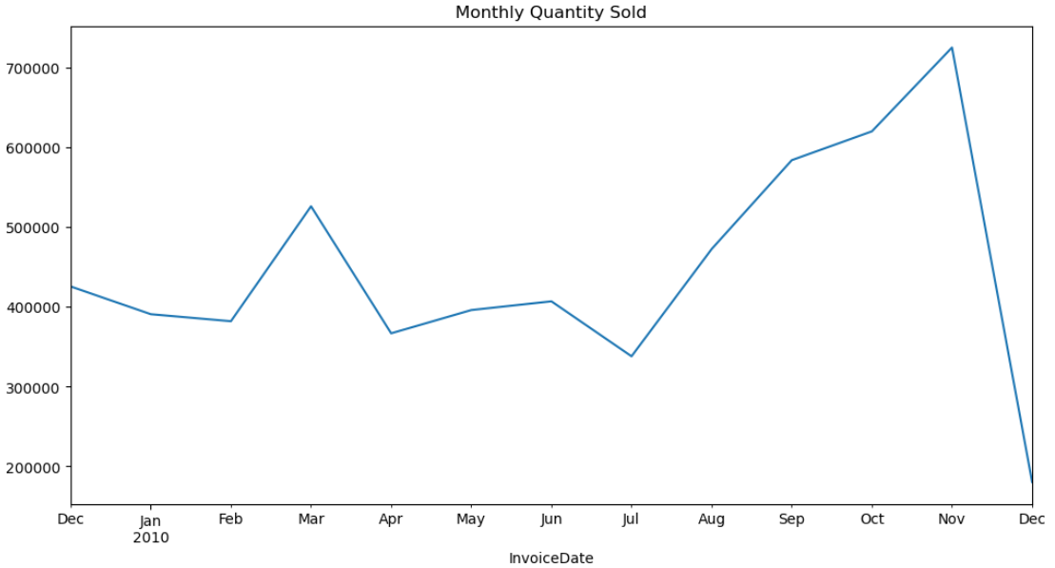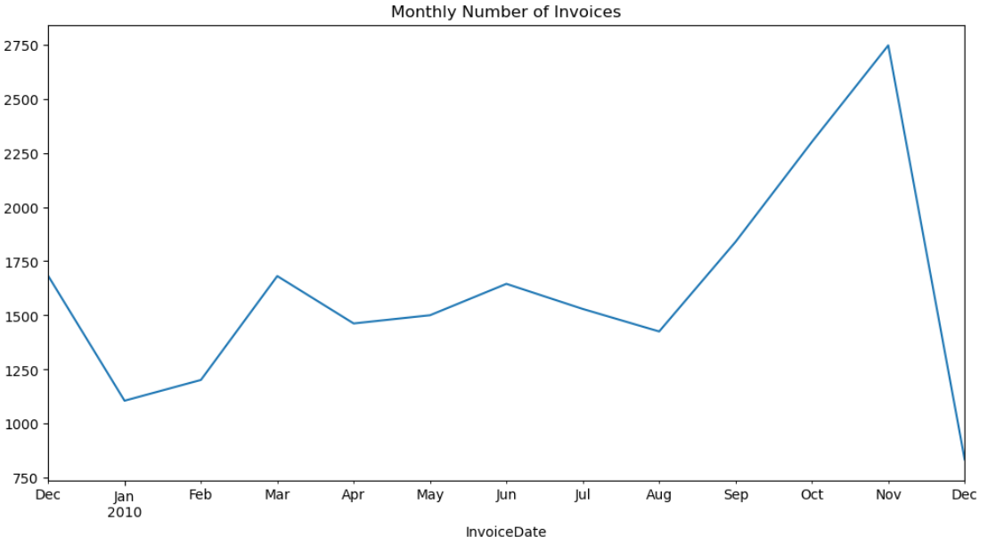
Figure 3: Monthly Revenue Figure 4: Monthly Quantity Sold Figure 5: Monthly Number of Invoices

Product Performance Analysis
Product analysis showed that product importance varies depending on revenue, quantity sold, and purchase frequency. Products such as WHITE HANGING HEART T-LIGHT HOLDER performed strongly across multiple categories. The analysis also identified administrative transaction codes such as POST, Manual, and AMAZONFEE, which were excluded from recommendation analysis because they do not represent real products.
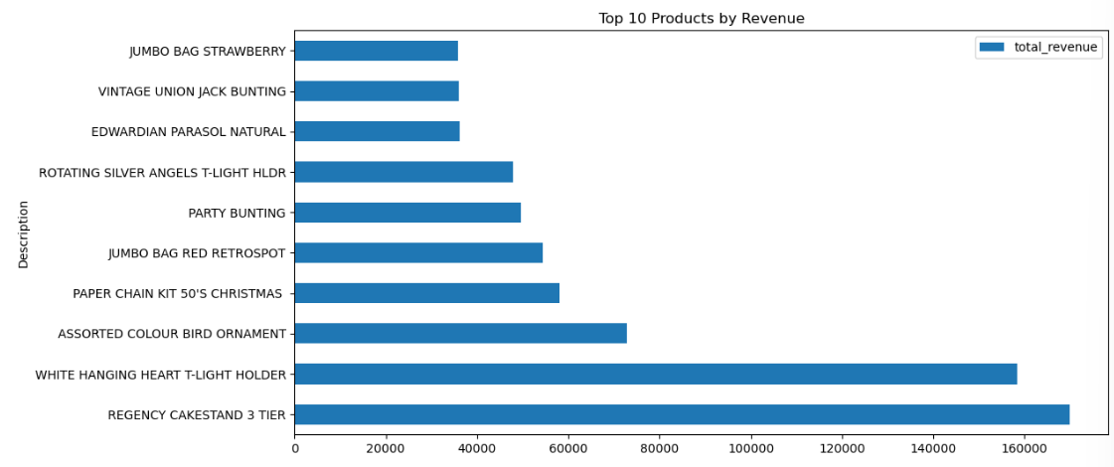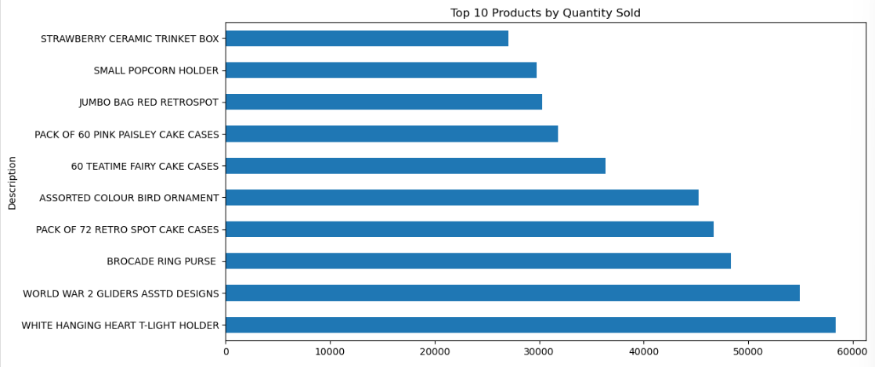
Figure 6: Top 10 Products by Revenue Figure 7: Top 10 Products by Quantity Sold

Customer Behaviour Analysis
Customer Behaviour Analysis huge differences between customers. While most of the customers generated moderate revenue, a small number of customers produced extremely high purchasing activity. The customer revenue distribution was heavily skewed, what supports the use of clustering techniques for customer segmentation.
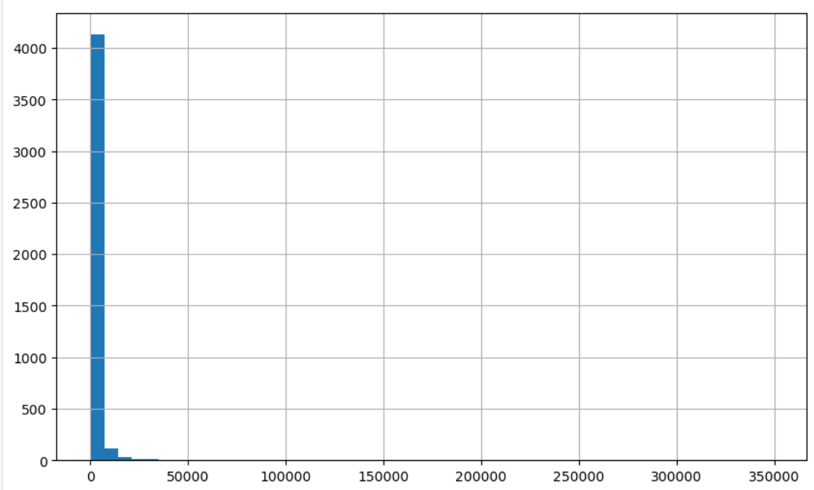
Figure 8: Customer Behaviour by Revenue

Basket Structure Analysis
Invoice analysis showed that 89,82% of invoices had more than one unique product. This indicates that customers usually buy more than one product at a time, and it confirms that the dataset is suitable for market basket analysis and recommendation modelling using association rules.
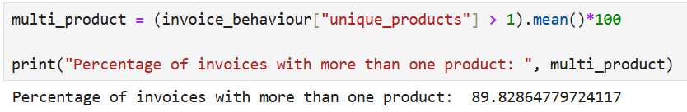
Figure 9: Percentage of Invoices with More Than One Product

Country Analysis
This analysis made clear that the UK data related dominates the dataset, it represents around 85,79% of total revenue, 92,07% of invoices, and 91,94% of identifiable customers. Because of this strong concentration, recommendation analysis will focus mainly on UK transactions in the future. The reason is to improve consistency and reduce regional imbalance.
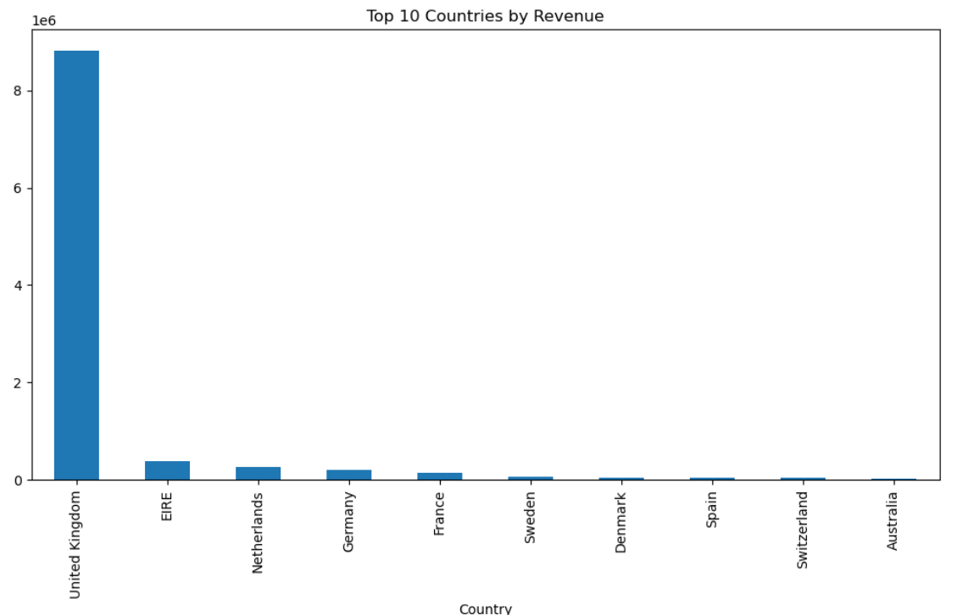
Figure 10: Top 10 Countries by Revenue

Data Quality
Many data quality issues were found during the exploration phase, including duplicated rows, missing descriptions, missing customer IDs, cancelled invoices, invalid prices, and negative quantities. A cleaning process was done to remove invalid transactions and create a reliable analytical dataset. The dataset was reduced in rows.
Outlier analysis also identified bulk purchases, high value invoices, and administrative transaction codes. These findings indicate that additional data preparation and scaling will be required during the modelling phase, especially for clustering.

Conclusion
CRISP-DM – Stage 2 -Data Understanding phase confirmed that the Online Retail II dataset is acceptable and suitable to achieve a successful implementation of customer segmentation, recommendation analysis, and retail business analytics.
The exploratory analysis demonstrated a clear customer variability, valuable co-purchase behaviour, and meaningful transactional patterns. With that in mind, customer segmentation combined with market basket analysis was chosen as the primary analytical goal of this project.
The next phase will be focused on Data Preparation, including feature engineering, RFM construction, scaling, outlier handling, and preparation of transactional basket structures for recommendation modelling.

CRISP-DM Stage 3 – Data Preparation
The Data Preparation stage served to transform the cleaned transaction dataset into modelling ready structures for customer segmentation and market basket analysis. Following the CRISP-DM, relevant data was selected, data was further cleaned, new features were added, and aggregation of transaction records into customer and invoice level datasets was done.

Select Data
The selected dataset was the cleaned Online Retail II transaction data. The retained columns were Invoice, Stock Code, Description, Quantity, Invoice Date, Price, Customer ID, Country and Revenue. These features were selected because they support the project objectives of analysing customer behaviour, product performance, and product associations.
Different subsets were created for different modelling purposes. For customer segmentation, only records with valid Customer ID values were selected. For market basket analysis, the dataset was filtered to include United Kingdom transactions only. This reduced country level imbalance and made the product association analysis more consistent.

Clean Data
The cleaning process fixed issues identified during data understanding, including duplicates, missing descriptions, missing customer identifiers, cancelled invoiced, negative quantities, invalid prices, and administrative transaction records. Duplicate rows were removed to avoid double counting. Rows with missing descriptions were removed as descriptions were required for product level analysis and basket matrix construction. Cancelled transactions, negative quantities, and invalid prices were excluded because the modelling focused on completed purchases.
For basket analysis, additional cleaning was done to remove non product records. If administrative items such as postage or bank charges were ignored then they would appear as recommended items or distort product relationships.

Construct Data
Many new features and modelling structures were created from the cleaned data. The first derived feature was Revenue (Quantity * Price). It’s an important feature required to measure customer spending and product performance.
For customer segmentation, the transaction data was converted into an RFM dataset. RFM means Recency, Frequency and Monetary value. Recency measured the number of days since a customer’s last purchase, Frequency measured the number of unique invoices per customer, and Monetary measured total customer spending.
The RFM were highly skewed. To reduce the influence of extreme high value customer, log1p() transformation was performed. This compressed large values while preserving customer ranking. After transforming the values, Standard Scaler was performed to standardise the RFM features.
For basket analysis, the UK transaction data was transformed into an invoice product matrix. Each row represented an invoice, and each column represented a product. Then the matrix was binary encoded, 1 meant a product was purchased and 0 to it was not.

Integrate Data
The final preparation step was aggregating transaction level records into modelling ready datasets. For customer segmentation, many transaction rows were grouped by Customer ID to create one RFM profile per customer. It was necessary because K-Means clusters customers, not individual transaction lines.
For market basket analysis, transaction rows were grouped by Invoice and Description to create the binary basket matrix required for Apriori. This allowed the model to detect which products appeared together within the same invoice.
The final prepared datasets were:
Dataset | Final Shape | Purpose
customer_df | 400,916 × 9 | Customer transaction records
rfm_df | 4,312 × 4 | Unscaled customer RFM profiles
rfm_scaled_df | 4,312 × 3 | K-Means input
uk_basket | 465,276 × 9 | Cleaned UK basket transactions
basket_matrix_encoded | 17,352 × 4,497 | Apriori input

To conclude the Data Preparation stage, two model ready datasets were produced: a scaled RFM dataset for K-Means customer segmentation and a binary UK basket matrix for Apriori association rule mining.

CRISP-DM Stage 4 - Modelling

CRISP-DM – Stage 5

CRISP-DM – Stage 6

References
Averageguymedianow (2025). Microsoft Azure vs AWS: A Comprehensive Comparison and When to Use Each. [online] Medium. Available at: https://medium.com/%40averageguymedianow/microsoft-azure-vs-aws-a-comprehensive-comparison-and-when-to-use-each-f70d0018c04d [Accessed 12 Mar. 2026].
bartenderpos (2025). Bartender POS. [online] BarTender POS. Available at: https://bartenderpos.com/gdpr-compliance-in-pos-systems/.
Bello, I. (2025). 6 Simple Steps of a SWOT Analysis. [online] Institute of Project Management. Available at: https://instituteprojectmanagement.com/blog/steps-of-a-swot-analysis/.
Collard, D. (2025). The Future of POS: How AI & Machine Learning Will Transform Retail & Hospitality. [online] Epos Now. Available at: https://www.eposnow.com/ie/resources/the-future-of-pos/ [Accessed 11 Mar. 2026].
GeeksforGeeks (2019). Comparisons between Azure Vs AWS. [online] GeeksforGeeks. Available at: https://www.geeksforgeeks.org/computer-networks/comparisons-between-azure-vs-aws/?utm_source=chatgpt.com [Accessed 12 Mar. 2026].
McGuire, S. (2025). POS system security: how to keep customer data safe in 2025 - Retail. [online] Retail Solutions. Available at: https://retailsolutions.ie/blog/pos-system-security-how-to-keep-customer-data-safe-in-2025/ [Accessed 12 Mar. 2026].
Refonte Learning (2025). Refonte Learning : Why Python Dominates Data Science in 2025: Key Trends & Insights. [online] Refontelearning.com. Available at: https://www.refontelearning.com/blog/why-python-dominates-data-science-in-2025-key-trends-insights?utm_source=chatgpt.com [Accessed 12 Mar. 2026].
Staff, C. (2025). Python Libraries for Data Analysis: Essential Tools for Data Scientists. [online] Coursera. Available at: https://www.coursera.org/articles/python-libraries-for-data-analysis?utm_source=chatgpt.com.

https://www.geeksforgeeks.org/data-analysis/rfm-analysis-analysis-using-python/
https://www.datacamp.com/tutorial/introduction-customer-segmentation-python?utm_cid=23781701478&utm_aid=196565213035&utm_campaign=260417_1-ps-dscia~amx-tofu~python_2-b2c_3-emea_4-prc_5-na_6-na_7-le_8-pdsh-go_9-nb-e_10-na_11-na&utm_loc=9042846-&utm_mtd=b-c&utm_kw=&utm_source=google&utm_medium=paid_search&utm_content=ps-dscia~emea-en~amx~tofu~tutorial~python&gad_source=1&gad_campaignid=23781701478&gbraid=0AAAAADQ9WsHEPfce-VUG2iV_E3PdmXvxd&gclid=CjwKCAjwt7XQBhBkEiwAtStpp1kt1aD4skl3BTzVlQaK-UUKiMFCKgPyhmF6cCrceOLbWLYiRAifthoCR50QAvD_BwE
https://www.investopedia.com/terms/r/rfm-recency-frequency-monetary-value.asp

ABOUT THE DATASET ONLINE RETAIL II:
https://www.codersarts.com/post/online-retail-dataset-classification-clustering-and-regression
https://medium.com/@E_godwin/analysis-of-an-online-retail-ii-uci-53b976f15232
https://medium.com/@mayureshrpalav/clustering-customers-online-retail-dataset-516e961e7bc
https://scikit-learn.org/stable/modules/generated/sklearn.cluster.KMeans.html
https://medium.com/learning-data/why-choosing-the-right-scaling-method-can-make-or-break-your-model-887c403dbcd0
https://numpy.org/devdocs/reference/generated/numpy.log1p.html
https://scikit-learn.org/stable/modules/generated/sklearn.preprocessing.StandardScaler.html

